**BANA 6760 Data Visualization**

**Assignment-11**

**Topic: Data Visualization with R studio**

**University of Colorado Denver**

**Department of Business Analytics**

**Submitted to**

**Professor: Dr. Ellis**

**Submitted By  
Sai Lokesh Siddanathi**

**Goal**: To Analyse the Customer Engagement and calculate the engagement summary.

**Charts Used:**

Bar Chart

Pie Chart

**1. Conversion Rate in Sales Channel:**

This Analyses the Engagement and the summary gives the enagagement summary.

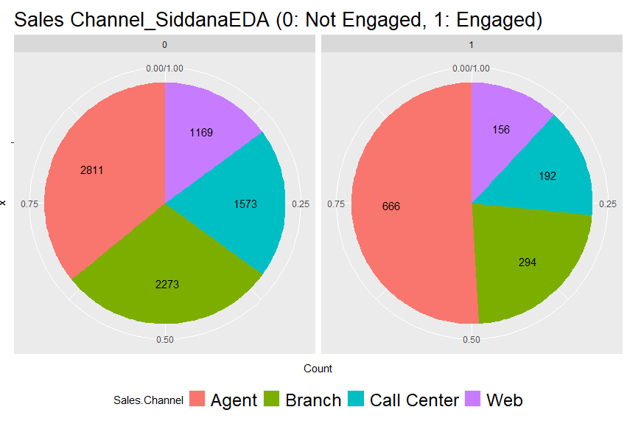

2. **Conversion Rate in State:**

This gives the conversion rate according to each state given in the dataset. Below graph shows that Doctor and Masters students has the high conversion rates.

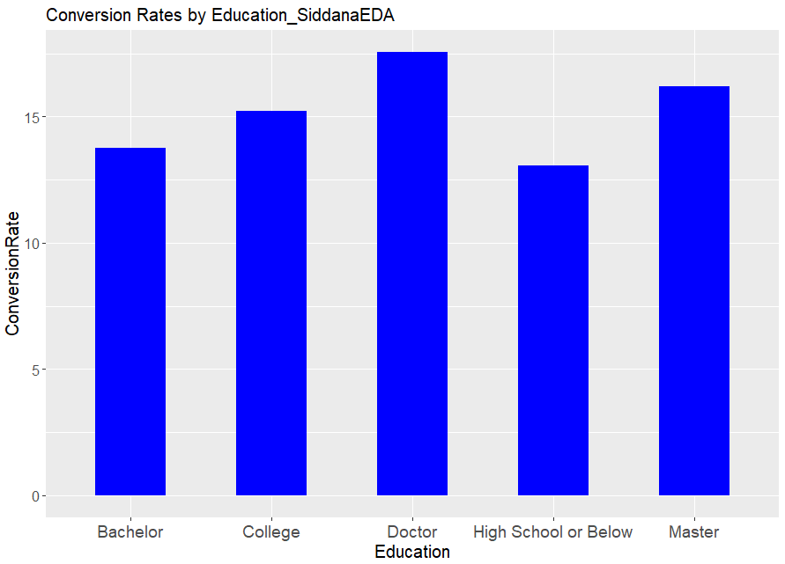

**3. Conversion Rate by Employment Status:**

Retired Employees are having the high conversion Rate. Below is the image for the reference.

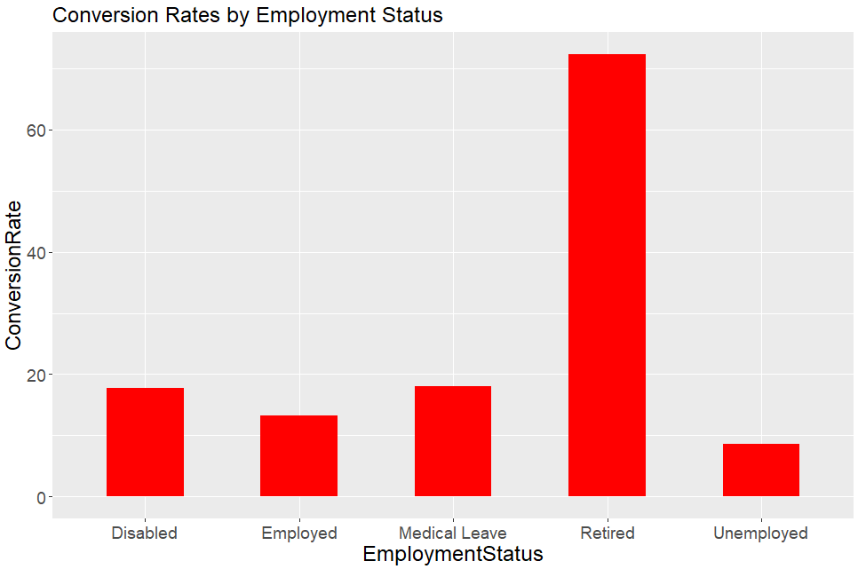

4. **Conversion Rate by Gender:**

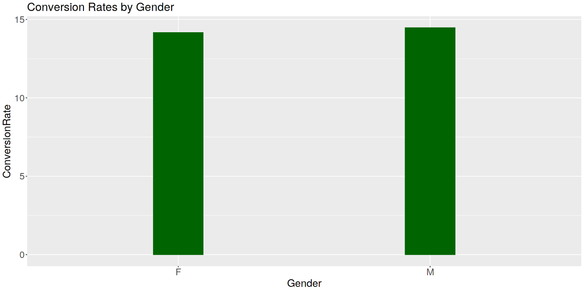

**5. Location Wise Conversion Analysis:**

This is the Conversion Rate across the locations. Suburban has the high rate compared to the rural and Urban areas.

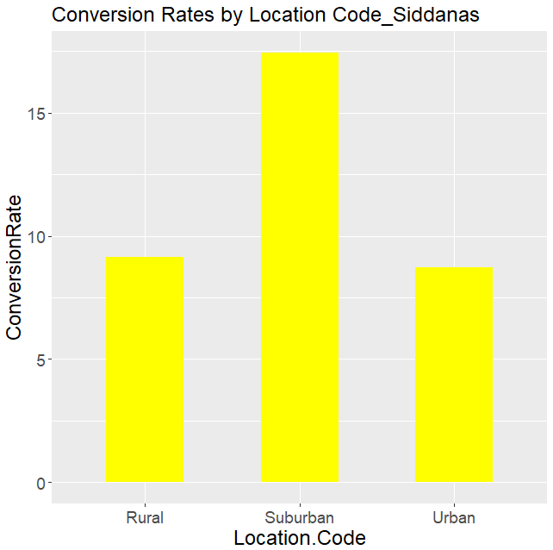

**Result:**

Regression Analysis for finding the significance of Variables and only Income, Number. Of. Policies, and Total Claim. Amount had significant correlations with the variable Engaged, according to the results of this regression study. Income and Total Claim. Amount are positively related to Engaged (coefficients are positive). That means that the higher our clients' income and total claim amount, the more likely they are to interact.